Bonus Section:
1. Implemented: Source Highlighting
Where:
src/rag_engine.py → inside answer_question() at the end.
Code snippet:
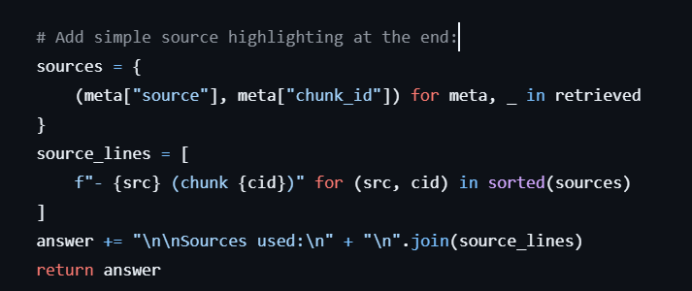

What it does:
- Takes all retrieved chunks (retrieved),
- Extracts (source, chunk_id) pairs,
- Deduplicates them using a set,
- Appends a “Sources used” section to the answer.
Difference from a plain RAG implementation:
- A plain/basic RAG answer would just return the LLM’s text. But this explicitly exposes which documents/chunks grounded the answer, which matches the bonus feature “Source highlighting”.

Bonuses that can be achieved:
2. Metadata Filtering
- Each chunk already has metadata fields like:
  - source (filename),
  - chunk_id,
  - start_word, end_word, etc.
- Method:
RAGEngine.retrieve(...) in src/rag_engine.py.

Pseudo-Code:
def retrieve(self, query: str, k: int = 5, filter_sources: Optional[List[str]] = None):
...
results = self.vector_store.search(query_emb, k=k)
filtered = []
for meta, score in results:
if filter_sources and meta["source"] not in filter_sources:
continue
filtered.append((meta, score))

3. Multi-Query Retrieval
- RAGEngine.retrieve() embeds only the original user query:
- query_emb = self.embedder.embed_text(query)
- results = self.vector_store.search(query_emb, k=k)
- No paraphrases or query expansion.
Extension:
- Adding a helper like _generate_alternative_queries().
- Extending retrieve() to optionally use multiple embeddings.
Pseudo-Code:
def _generate_alternative_queries(self, query: str) -> List[str]:
# using LLM to create 2-3 paraphrases
...
def retrieve(self, query: str, k: int = 5, use_multi_query: bool = False):
queries = [query]
if use_multi_query:
queries.extend(self._generate_alternative_queries(query))
embeddings = self.embedder.embed_texts(queries)
aggregated = {}
for emb in embeddings:
results = self.vector_store.search(emb, k=k)
for meta, score in results:
key = (meta["source"], meta["chunk_id"])
if key not in aggregated or score > aggregated[key][1]:
aggregated[key] = (meta, score)
# converting dict to sorted list
return sorted(aggregated.values(), key=lambda x: x[1], reverse=True)[:k]

4. Context Compression
Pseudo-Code:
def _compress_context(self, retrieved: List[Tuple[Dict, float]]) -> str:
# Concatenate texts
all_text = "\n\n".join(meta["text"] for meta, _ in retrieved)
prompt = (
"Summarize the key points from the following documentation chunks "
"so that another model can answer a question based on the summary.\n\n"
f"{all_text}"
)
response = self.llm_client.chat.completions.create(
model=self.llm_model_name,
messages=[
{"role": "system", "content": "You compress context for downstream QA."},
{"role": "user", "content": prompt},
],
temperature=0.3,
)
return response.choices[0].message.content.strip()

- Then in answer_question():

def answer_question(self, query: str, top_k: int = 5, use_context_compression: bool = False):
retrieved = self.retrieve(query, k=top_k)
...
if use_context_compression:
context_for_prompt = self._compress_context(retrieved)
else:
context_for_prompt = self._build_context_block(retrieved)

